Physics and Math Integration Using Digital Tools
W. H. M. FEU
Departamento de Física, CEFET-MG, Belo Horizonte, MG, Brazil
F. A. CASTRO, J. B. Q. ZULIANI
Departamento de Formação Geral, CEFET-MG,Timóteo, MG, Brazil
E-mail: feu@cefetmg.br
Abstract. In this paper we present an experience report of a project based on integrated activities in physics and mathematics using softwares of motion analysis and computational modeling. The activities were performed by first-year high school students in a public school with technical courses integrated, in Brazil.
The Common National Curricular Basis [1], or BNCC, is a document provided by Brazilian Ministry of Education and concerns public policies for education and the development of curriculum proposals at elementary and high school levels. It proposes a consolidation, amplification, and reinforcement of the essential learning tools developed in the previus school years. Aiming to enable a more integrated vision of education, it proposes an interconected perspective of the school subjects.
Despite the integrative perspective, the reality is that, however connected or common the topics may be in physics and mathematics, they’re not presented in means students can make associations and consolidate the concepts. Linear and quadratic functions, for instance, are alike topics in both subjects, but are seen in physics before they are presented in mathematics. Also, the consolidation of new concepts introduced in physics, such as velocity and acceleration with linear and quadratic functions, prove to be a challenge for students in public schools [2].
Many authors point out that one reason for students struggle is that those concepts are distant from students’ reality [2]. Thereby, we propose an integrative project, associated with the use of technology, with activities using the softwares Tracker and Geogebra. This paper presents an experience report, and its main results, and opens a perspective for future investigation.
The project was developed with first-year high school students from a Brazilian public school with technical courses integrated. The students come from multiple social backgrounds. It was performed in three sequencial years, with subtle differences but the same main structure.
In the first year, the students recorded a video of a ball thrown horizontally. It was the same video for all the students. Using the software Tracker [3], students studied each component of the movement, horizontal and vertical, and its independencies, as seen in Fig. (1). They discussed the mathematical models given by kinematic equations and then simulate, using the software Geogebra [4].
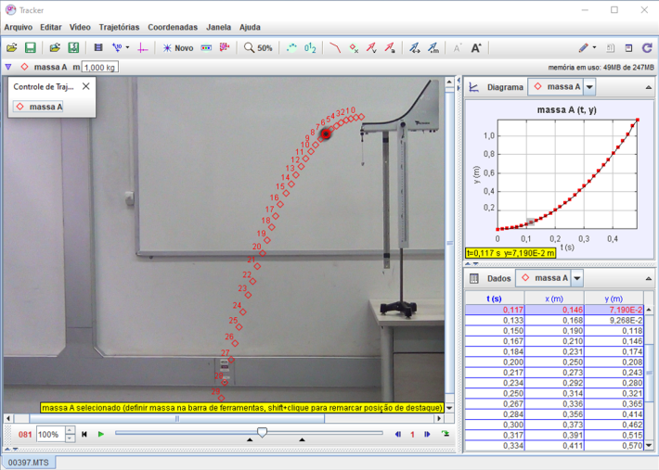
Figure 1. Print of the software Tracker screen of ball thrown horizontally.
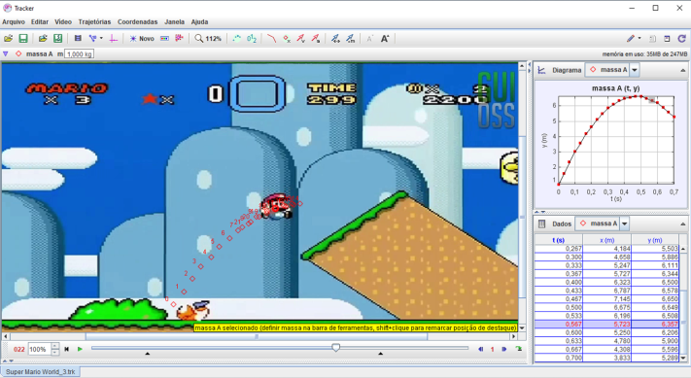
Figure 2. Analysis of a parabolic motion from a scene of a game.
In the second and third years, the movement recorded was changed. In one of the situations students selected a scene from a game of their preference in which something had a horizontal and vertical motion, shown in Fig. (2). On the other, students recorded with their mobiles an everyday situation involving a free fall or two dimensional motion, seen in Fig. (3).
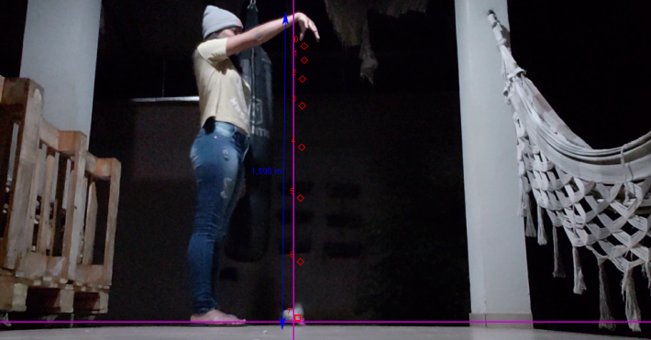
Figure 3. Analysis of an object in freefall.
The development of this project provided a way to explore conjectures. Something natural in physics and mathematics, but unusual in our daily traditional classes. And the search for answers to such conjectures has shown a great opportunity for a rich learning environment.
During the performance of this work, the students were able to engage in discussions in order to comprehend the physical fenomena instead of solving conventional problems which sometimes are just a “bureaucratic” task of getting questions right.
We also found out that the teaching of physics and mathematics in a detached way creates in the students obstacles in interpreting and understanding concepts and usual language. Our results suggest a high efficiency in using computational resources like Tracker and GeoGebra in integrated classes of physics and mathematics. More research is needed to measure the quantitative results.
Keywords. Computational Modeling, Information and Communication Technology, Integration between Physics and Maths.
References (and Notes)
[1] Brasil. (2017) Base Nacional Comum Curricular: Ensino Médio. Brasília: MEC/Secretaria de Educação Básica. Available at http://basenacionalcomum.mec.gov.br/ (Accessed: 02 June 2020).
[2] Souza, P. V. S.; Donangelo, R. ‘Velocidades média e instantânea no Ensino Médio: uma possível abordagem’ Rev. Bras. Ensino Física, 2012, 34(3), 1-6. Available at: http://dx.doi.org/10.1590/S1806-11172012000300017 (Accessed: 28 October. 2019).
[3] TRACKER. Available at: http://physlets.org/tracker/ (Accessed: 02 June 2020).
[4] GEOGEBRA. Available at: https://www.geogebra.org/ (Accessed: 02 June 2020).

