Micropropagation and *Agrobacterium*-mediated Transformation of Plant Model *Marchantia polymorpha* L.

*A. Séneca, B. Pires, S. Pereira, C. Pereira*

*GreenUPorto-Sustainable Agrifood Production Research Cente Center, Faculdade de Ciências da Universidade do Porto, Rua do Campo Alegre, s/nº, 4169-007 Porto, Portugal*

*aseneca@fc.up.pt*

**Abstract.** We developed a project for high school and college students pertaining the concepts and procedures involved in plant micropropagation and plant genetic transformation using the model plant *Marchantia polymorpha*. Genetic engineering, the process of manipulating the DNA of an organism often including DNA from a foreign organism, relies on complex molecular techniques. Students conduct hands-on experiments involving establishing plant tissue cultures in aseptic conditions and DNA-based technologies including Agrobacteria-mediated transformation of plants, and observation of fluorescent recombinant proteins by fluorescence microscopy. The impact of these technologies is discussed enabling students to address these controversial issues and justify their decisions on scientific-based balanced appraisals.

**Keywords.** Agrobacteria-mediated transformation, *Marchantia polymorpha*, Micropropagation, Green fluorescent protein (GFP).

**1. Introduction**

**1.1. Biotechnology Education**

Biotechnology has an increasing social impact in daily lives requiring citizens to be able to understand its main concepts and make informed decisions regarding its applications. However, an extended survey on Portuguese high-school students ‘perceptions about biotechnology showed that the students displayed misconceptions about fundamental concepts and principles [1].

The field of biotechnology relies on complex molecular techniques, such as genetic engineering, as a process of manipulating the DNA of an organism often including DNA from a foreign organism. The subject of genetically modified organisms, or GMOs, has sparked public controversy but most current misconceptions derive from nonscientific acquired from sources other than scientific education.

Science teaching, namely in the biotechnology field, must include innovative teaching strategies and the discussion of social and environmental consequences of biotechnology applications. Students should be engaged in hands-on-laboratory classes and involved in investigations over long periods of time in the context of inquiry.

We developed a project for 16 years over students (high school and college levels) aimed at conveying the principles involved in plant genetic transformation. Combine cutting-edge science with simpler activities the students conduct hands-on experiments involving plant tissue culture, plant genetic engineering via *Agrobacterium tumefaciens* bacteria and observation of expressed fluorescent recombinant proteins in plant cells at the fluorescence microscope. Additionally, students learn how to aseptically cultivate bacteria and obtain axenic culture of plant tissues.

**1.2. *Agrobacterium tumefasciens* as “Nature’s own genetic engineer”**

*Agrobacterium tumefasciens* is a bacterium that occurs naturally in the soil and is able to transfer a region of its own DNA into the plant cells causing rapid cell division and the formation of tumors. This led to the denomination of *Agrobacterium* as “Nature’s own genetic engineer”. In plant genetic engineering *A. tumefasciens* is used as vector to transfer genes of interest into plant cells. The process of transformation involves engineering, the bacteria Ti plasmid (Ti for Tumor –induction) inserting a genetic construct containing the gene of interest coding for the protein to be expressed [2].

**1.3. *Marchantia polymorpha* as an emerging plant model**

Until recently, research in the laboratory using transgenic plants relied mainly in the model plants *Arabidopsis thaliana* and *Nicotiana tabaccum*, both flowering plants. With the increasing number of sequenced plant genomes, other species are being used for transformation, including other emerging model plants such as *Physcomitrella patens* and *Marchantia polymorpha*, both bryophytes, an early group of land plants [3]. *Marchantia polymorpha* is a widely distributed liverwort that grows in somewhat shaded moist soils and rock surfaces, often in greenhouses.

The life cycle involves an alternation between the a dominant gametophytic haploid fase and a short lived diploid sporophytic phase, Fig. 1. The mature plant body, the gametophyte, is a simple thalloid structure consisting of many differentiated cell types. Plants can be asexually propagated through gemmae that are produced from single epidermal thallus cells and cluster inside gemma cups. The species is diploid, producing male and female gametophytes. The sexual reproduction involves the development of sex organs, archegonia and antheridia in stalked structures developed at the surface of the thallus. Fertilization is strictly dependent on the presence of a water film through which the male gametes reach the oosphere inside the female sex organ, the archegonium. The fertilized oosphere develops into a short lived sporophyte consisting of little else other than a sporangium. Inside the sporangium the spore mother cells undergo meiosis producing haploid spores, which, upon germination produce new thaloid gametophytes. 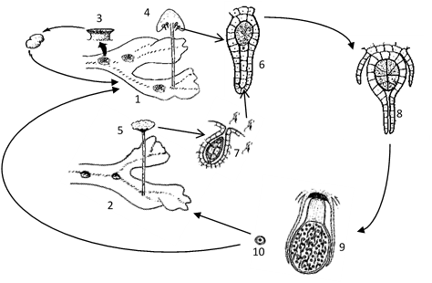

**Figure 1. *Marchantia polymorpha* life cycle: 1 – female gametophyte; 2- male gametophyte; 3 – gemma cup producing haploid gemmae; 4 – archegoniophore; 5 -.antheridiophore; 6 – archegonium; 7 – antheridium; 8 – fertilized archegonium; 9 – diploid sporophyte with a sporangium; 10 – spore**

Reproductive growth can be induced under laboratory conditions. A change in light quality induces sexual reproduction, and male and female plants differentiate sexual organs [4].

*M. polymorpha* is progressively becoming a model system for plant transformation because of its haploid vegetative growth, small genome size (approx. 280 Mb) and no evidence of ancient genome duplications [5]. In addition, the short life cycle, the ease of clonal propagation by means of the multicellular gemmae, the ease of crossing and the high frequency of genetic transformation allowing for a rapid verification of the question under study, are further advantages to use this species as a system for plant transformation [6]. The *M. polymorpha* thallus can be maintained and propagated asexually by transferring excised thallus fragments or gemmae into liquid or solid synthetic growth media without vitamin supplements or the application of growth regulators. Material from axenic cultures can then be propagated using the same procedures which allows the maintenance of genetic homogenous individuals and lines at lower costs that that for flowering plants [7].

**1.4. Molecular tools and *Agrobacterium*-mediated transformation**

Molecular tools become increasingly available, namely fluorescent proteins and selectable markers [4]. Availability of molecular techniques, including transformation technologies are available for *M. polymorpha*, making this model plant suitable for evolutionary, molecular, cellular and developmental studies [4,7].

Simple and efficient protocols of *Agrobacterium*-mediated transformation have been established allowing introduction of reporter constructs and overexpressing proteins. Transgenic haploid lines can be produced in four to six weeks [7]. Common binary vectors developed for other plant systems, can be used for *M. polymorpha* transformation. Widespread CaMV 35S constitutive promoter has been shown to be capable of driving strong expression in *M. polymorpha*and various marker genes have been used for selection with hygromycin, gentamicin, chlorsulfuron and G418 [7]. With *Agrobacterium* - mediated transformation protocols, it takes 2–3 weeks to obtain a transgenic plant on the first selection plate, and additionally 2–3 weeks to establish isogenic G1 lines [7].

In this work, students will culture *Agrobacterium* clones kept in the laboratory harboring constructs coding for fluorescent protein GFP (green fluorescent protein) fused with different intracellular targeting domains, specific for intracellular compartments such as Endoplasmic Reticulum (ER). We used a common construct (Fig. 2) with widespread use as endoplasmic reticulum (ER) marker. This yields green fluorescence protein (GFP) localized in the ER. The GFP variant used, mGFP5-ER, is suitable for expression in plant cells. The addition of a N-terminal signal peptide (SP, Fig. 2) induces translocation across the ER membrane and a C-terminal C-terminal fusion of the amino acids HDEL results in retention of GFP within the lumen of the endoplasmic reticulum. The coding sequence of the ER-localized GFP variant (mGFP5-ER) is cloned in a binary transformation vector pVKH18 behind an enhanced cauliflower mosaic virus (CaMV) 35S promoter to generate pVKH-GFP-HDEL available from Oxford University [8].

**Figure 2. Construct coding for fluorescent protein GFP fused with intracellular targeting domains, specific for targeting and retention in the Endoplasmic Reticulum (ER). SP,Signal peptide for targeting to the ER; GFP, Green Fluorescent Protein; HDEL, aminoacidic motif in the C-terminal end for ER-retention**

**2. Materials and Methos**

**2.1 Axenic cultures of *Marchantia polymorpha* from gemmae**

*Marchantia polymorpha* specimens were collected in the University campus in Porto.

Gemmae were extracted from gemma cups by adding a drop of sterilized hydrogen peroxide solution 3% (v/v) to allow the emergence of the gemmae from the cup [9]. Gemmae were then collected with a small sterilized brush into a 1 % (v/v) solution of sodium hypochlorite, shaken for 1 min and further rinsed twice in sterile deionized water. The gemmae cultures were established in half-strength Gamborg’s B5 (1/2 B5) basal medium, without vitamin supplements (Duchefa Biochemie), 0.5 % (w/v) MES, 1 % (w/v) sucrose, 1.3 % (w/v) agar, pH 5.7 in 90-mm disposable sterile Petri dishes [10]. The gemmae were delivered over a drop of sterilized water previously placed on the solid medium surface and spread evenly over the plate. *M. polymorpha* gemmae cultures were illuminated with 110 µmol/m².s under continuous white light (OSRAM L 36W/77 e OSRAM L 36W/840), in a culture room maintained at around 22 ° and approximately 60% humidity.

**2.2 Tranformation of gemmae by G-AgarTrap technique**

Like the general *Agrobacterium*-mediated transformation procedure, AgarTrap consists of three steps: (1) pre-culture of *M. polymorpha* tissue, (2) co-culture of the tissue with *Agrobacterium* containing recombinant T-DNA, and (3) selection of transgenic cells. A unique feature of AgarTrap is that none of these steps requires liquid medium culture; rather the appropriate solutions are simply poured onto the solid medium in a single Petri dish [9,11]. AgarTrap involve three major steps: (1) plating of *M. polymorpha* tissue, (2) pouring transformation buffer, and (3) pouring selection buffer. A flowchart of the AgarTrap procedure and post-operations is shown in Fig. 3

Sowing *M. polymorpha* gemmae on ½ B5 medium + 1% sucrose medium

Pouring transformation buffer

*Agrobacterium* strain GV3101::pMP90 with GFP-HDEL

Washing and pouring selection buffer

Streaking *Agrobacterium*  on LB solid medium

**III**. Selection: 2 weeks

**I**. 2-3 days at 28°C

**I**. Preculture: 2 days

**II**. Co-culture: 2 days darkness

**Figure 3. Flow chart of the Agar Trap method for *M. polymorpha* gemmae transformation. I- Pre culture of gemmae in ½ strength B5 medium with 1% sucrose and *Agrobacterium* cultures in LB medium; II – Co-culture of *M. polymorpha* and *Agrobacterium* in ½ strength B5 medium with 1% sucrose in darkness; III - Washing of the gemmalings and selection of transgenic cells on the same culture medium (Adapted from [9])**

**2.1. Pre-culture of gemmae and *Agrobacterium* culture**

*M. polymorpha* gemmae were precultured for three days in ½ strength B5 Gamborg’s growth medium with 1% sucrose (see 1 for details and growing conditions). *Agrobacterium tumefaciens* strain GV3101::pMP90 with GFP-HDEL marker was grown in LB growth medium supplemented with gentamicin (20 mg/L) and kanamicin (50 mg/L), overnight at 28 °C shaking.

**2.2. Infiltration of gemmae with *Agrobacterium***

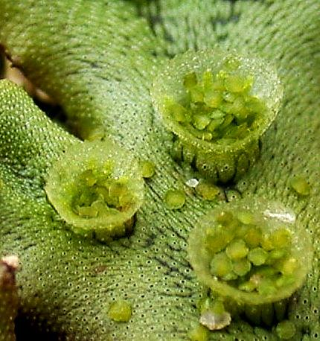The infiltration step consists in the uptake of the *Agrobacterium* carrying the GFP-HDEL marker the by the *M. polymorpha* cells This uptake is facilitated by an infiltration buffer (10 mM de MgCl2, 10 mM de MES-NaOH, pH 5,7; 10x) The *Agrobacterium* culture was centrifugated at maximum speed for 3 minutes. The supernatant was discarded and 1mL of the infiltration buffer was added, followed by another centrifugation step during 1 minute, as a wash step. After adding acetosyringone (150 µM) to the infiltration buffer, 1 mL of this buffer was added to the bacterial sediment and the bacteria re-suspended. Optimal optical density (λ= 600 nm) for the infiltration mix was adjusted to 0.5-1. Into the gemmae plates was pipetted 1 mL of the infiltration mix and the plates subjected to vacuum for 1 minute, to improve infiltration success. The excess of infiltration mix was pipetted out from the plates and these were left to grow in darkness, at 22°C, for 3 days.

**2.3. Selection and isolation of transformed gemmae**

The plates were first washed twice with sterile deionized water, followed by the addition of 1 mL of selection buffer (10 mM MgCl2, 10 mM MES-NaOH, pH 5,6, supplemented with hygromicin (10 µg/mL) and cefotaxime (1 mg/mL). The gemmae were grown in the same conditions described in 1, for two weeks. After this period the gemmae were transfered to plates with ½ strength B5 Gamborg’s growth medium without sucrose (see 1 for details and growing conditions) and supplemented with hygromicin (10 µg/mL) and cefotaxime (1 mg/mL), and left to grow for another two weeks in the same conditions as above.

Gemmae with visible growth of helathy green tissue were then isolated in plates containing ½ strength B5 Gamborg’s growth medium without sucrose (see 1 for details and growing conditions) supplemented with just hygromicin (10 µg/mL).

**3. Results**

**3.1 Established axenic cultures of *M. polymorpha* from gemmae**

Gemmae were extracted from gemma cups (Fig.3), sterilized and sown in ½ strength B5

with 1% sucrose. After 2-3 days it is visible that the gemmae start to regenerate thallus tissue by activating cell division at the notches (Fig. 4A arrows), and, after 2 weeks, the initial

**Figure 3 –Detail of the surface of the thalloid gametophyte showing gemma cup with gemmae;**

gemmae had grown into fully differentiated thalloid gametophytes (Fig 4B). These new gemmae or thallus can be used for further propagation, allowing the production of genetic homogeneous clones.

**3.2 Transformation of *M. polymorpha* gemmae by the Agar Trap method**

Precultured gemmae (Fig. 3) were transformed pouring an *Agrobacterium* culture containing GFP_HDEL marker and infiltration solution into the growing plate and incubated in darkness for two days.

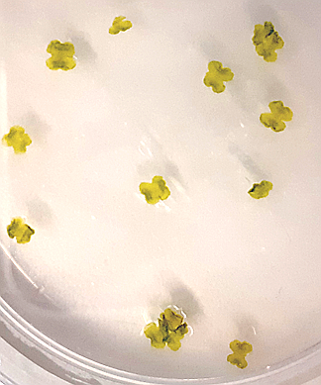

A

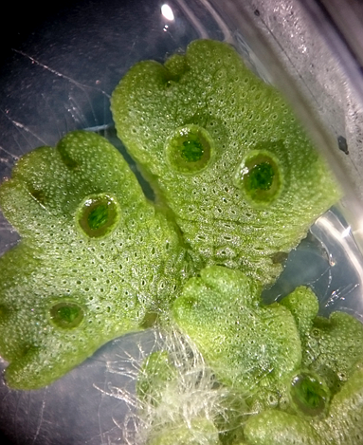

B

**Figure 4 – A: gemmae growth after 3 days in culture (arrows: growth points at the notches); B – regenerated thalloid gametophytes with gemmae cups after two weeks in culture**

**Figure 5 – Different aspects of the gemmae during the transformation process: A – precultured gemmae; B – Gemmae after the selection step showing large parts of necrotic tissue and growth of the transformed cells; C – Fully developed gametophytes 2 weeks after isolation of the positive clones**

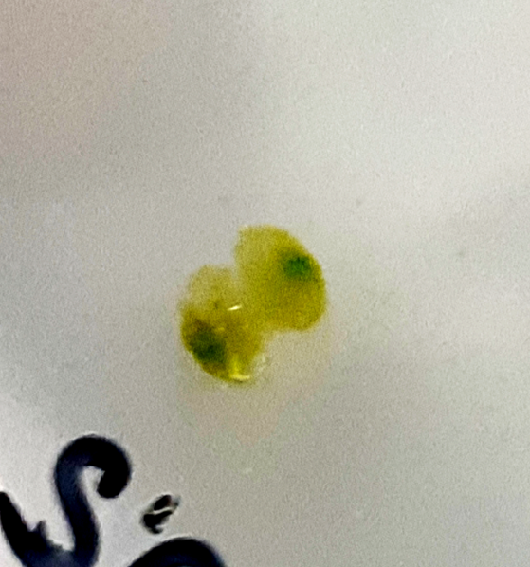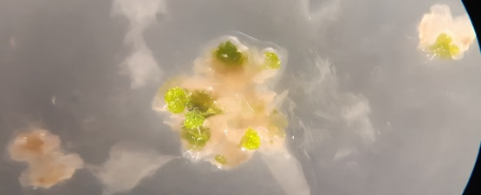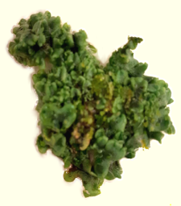

C

B

A

After adding the selection solution and resuming growth under standard light and temperature conditions the tissues suffered several alterations, from the initial green healthy gemmae (Fig 5A) to mostly necrotic tissue as the antibiotics in the selection solution killed all non- transformed cells, leaving a small unnoticeable percentage of cells alive. After 2 weeks the transformed cells started to produce green photosynthetic tissues (Fig. 5B). Fully developed gametophyte thalli were obtained two weeks after selection and isolation of positive clones (Fig. 5C).

Fragments of transformed *M.polymorpha* thallus were observed under a fluorescence microscope to visually confirm the incorporation of the GFP-HDEL marker into the cells during the transformation process. Even though these photosynthetic tissues have a high degree of

**Figure 5 – Transformed *M.polymorpha* gemmae tissue observed under the fluorescence microscope. Note the characteristic marking of the endoplasmic reticulum as the network marking of GFP (arrow)**

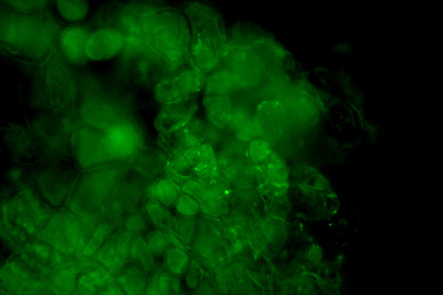

auto fluorescence, in Fig 5 it is possible to observe GFP fluorescence within the endoplasmic reticulum. The fluorescence marking of GFP appears as a network across some points of at cell surface which is the characteristic location of the endoplasmic reticulum within the cell

**4. Discussion**

In this work, we propose a multidisciplinary long hands-on ,project for students of high school and college levels aimed at conveying the principles involved in plant micropropagation and genetic transformation, as well an approach to plant cell structure and cell biology. Students will be involved in bacterial cell cultures, plant culture techniques in aseptic conditions, genetic manipulation, recombinant protein expression, fluorescent protein reporters, and fluorescence microscopy. This laboratory activity will introduce students to a broad array of concepts and applications.

Plant tissue culture represents a most promising area and ranges from micropropagation of economical important species like ornamental and forest trees, production of pharmaceuticals, and improvement of nutritional value of crop plants. In vitro cell and tissue culture methodology is also a mean of germplasm conservation to ensure the survival of endangered plant species. The concept of cloning organisms is particular evident with the applied technique of micropropagation in which isogenic lines of genetically identical cells are obtained and cloned plants produced that are genetically homogeneous individuals, identical to the original genotype [12].

All biotechnological approaches like genetic engineering, depend on an efficient *in-vitro* plant regeneration system. Genetic transformation relies on plant cell and tissue culture and allows the transfer of genes with desirable trait into host plants and recovery of transgenic plants [12].

The endoplasmic reticulum (ER) of the *M. polymorpha* cells could be easily visualized using green fluorescent protein (GFP) fused with a ER targeting signal peptide and the HDEL retaining signal. This not only allowed an easy, direct means of observing the result of the transformation process and but also to discuss plant cell structure and determinants of intracellular protein trafficking.

Depending on students’ level and time available, the project can be extended to detect transgene insertion in plant genome by PCR using available primers to GFP. This extension can be used to introduce GMO (Genetic Modified Organisms) and simple molecular techniques available for GMO detection.

Encompassing the laboratory process, students are invited to list and discuss the pros and cons of these technologies as several uses of transgenic plants have great impact, namely the production of beneficial proteins in agriculture, the production of plant manufactured pharmaceuticals used as therapeutic compounds, and basic cell and molecular biology research. Ethical issues of the impact of these technologies can be further discussed, namely the possible social and environmental consequences.

. **5. References**

[1] Fonseca MJ, Costa P, Lencastre L, Tavares F. Multidimensional analysis of highschool students' perceptions about biotechnology. Journal of Biological Education, 2012; 46 (3), 129-139.

[2] Runions CJ, Hawes C, Kurup S. Fluorescent protein fusions for protein localization in plants. In: van der Giezen M (Editor) Methods in Molecular Biology. Vol. 390 - Protein Targetting Protocols, New Jersey: Humana Press; 2007.

[3] Afroz A, Saumya P. *Marchantia polymorpha* L.: An Emerging Model Plant System to Study Contemporary Plant Biology – A Review. Plant Science Today,2016, 3. 88-99. 10.14719/pst.2016.3.2.221.

[4] Berger F, Bowman JL., Kohchi T. *Marchantia*. Current Biology, 2016, 26(5), R186-R187.

[5] Bowman JL, Sakakibara K, Furumizu C,.Dierschke T. Evolution in the cycles of life. Annu. Rev. Genet.,2016, 50, 133-154.

[6] Poveda J. *Marchantia polymorpha* as a model plant in the evolutionary study of plant-microorganism interactions. Current Plant Biology, 2020, (article in press, corrected proof) https://doi.org/10.1016/j.cpb.2020.100152

[7] Ishizaki K, Nishihama R, Yamato KT, Kohchi T. Molecular Genetic Tools and Techniques for *Marchantia polymorpha* Research. Plant Cell Physiol.,2016, 57(2):262‐270. doi:10.1093/pcp/pcv097

[8] Batoko H, Zheng HQ, Hawes C, Moore I. A rab1 GTPase is required for transport between the endoplasmic reticulum and golgi apparatus and for normal golgi movement in plants. Plant Cell., 2000;12(11):2201-2218. doi:10.1105/tpc.12.11.2201

[9] Tsuboyama S., Nonaka S., Ezura, Kodama Y.Improved G-AgarTrap: A highly efficient transformation method for intact gemmalings of the liverwort *Marchantia polymorpha*.Sci Rep, 2018,8,10800 <https://doi.org/10.1038/s41598-018-28947-0>

[10] Tsuboyama S, Kodama Y. AgarTrap Protocols on your Benchtop: Simple Methods for *Agrobacterium*-mediated Genetic Transformation of the Liverwort *Marchantia polymorpha*. Plant Biotechnol, 2018, 35(2):93-99. doi:10.5511/plantbiotechnology.18.0312b

[11] Tsuboyama S, Kodama Y. AgarTrap-mediated genetic transformation using intact gemmae/gemmalings of the liverwort *Marchantia polymorpha* L. J Plant Res., 2015, 128(2):337-344. doi:10.1007/s10265-014-0695-2

[12] Hussain A, Qarshi I, Nazir H, Ullah I. Plant Tissue Culture: Current Status and Opportunities, Recent Advances in Plant in vitro Culture, 2012, Annarita Leva and Laura M. R. Rinaldi, IntechOpen, DOI: 10.5772/50568