Do you want to learn? Pick up you smartphone and lets go to the park

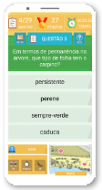
This is the proposal of the EduPARK project.
Anyone with an Android mobile device can download the EduPARK app (http://edupark.web.ua.pt/mobile_app?lang=en), download its associated quizzes and go to the Infante D. Pedro Park (in Aveiro) to learn Science, Mathematics, History and other subjects in a fun and healthy way.
Not in a mood to play a game to learn? Not a problem, you can still use the “Explore freely” tool to explore the augmented reality educational resources of the park.
So… What are you waiting for? Let’s go to the park!

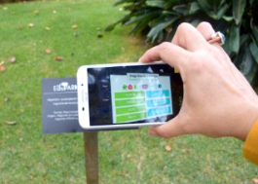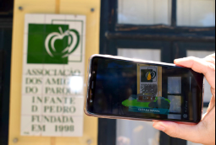

Do you want to know more about EduPARK? You have all information about the project in its latest book, https://ria.ua.pt/handle/10773/26979 (in Portuguese) and website

