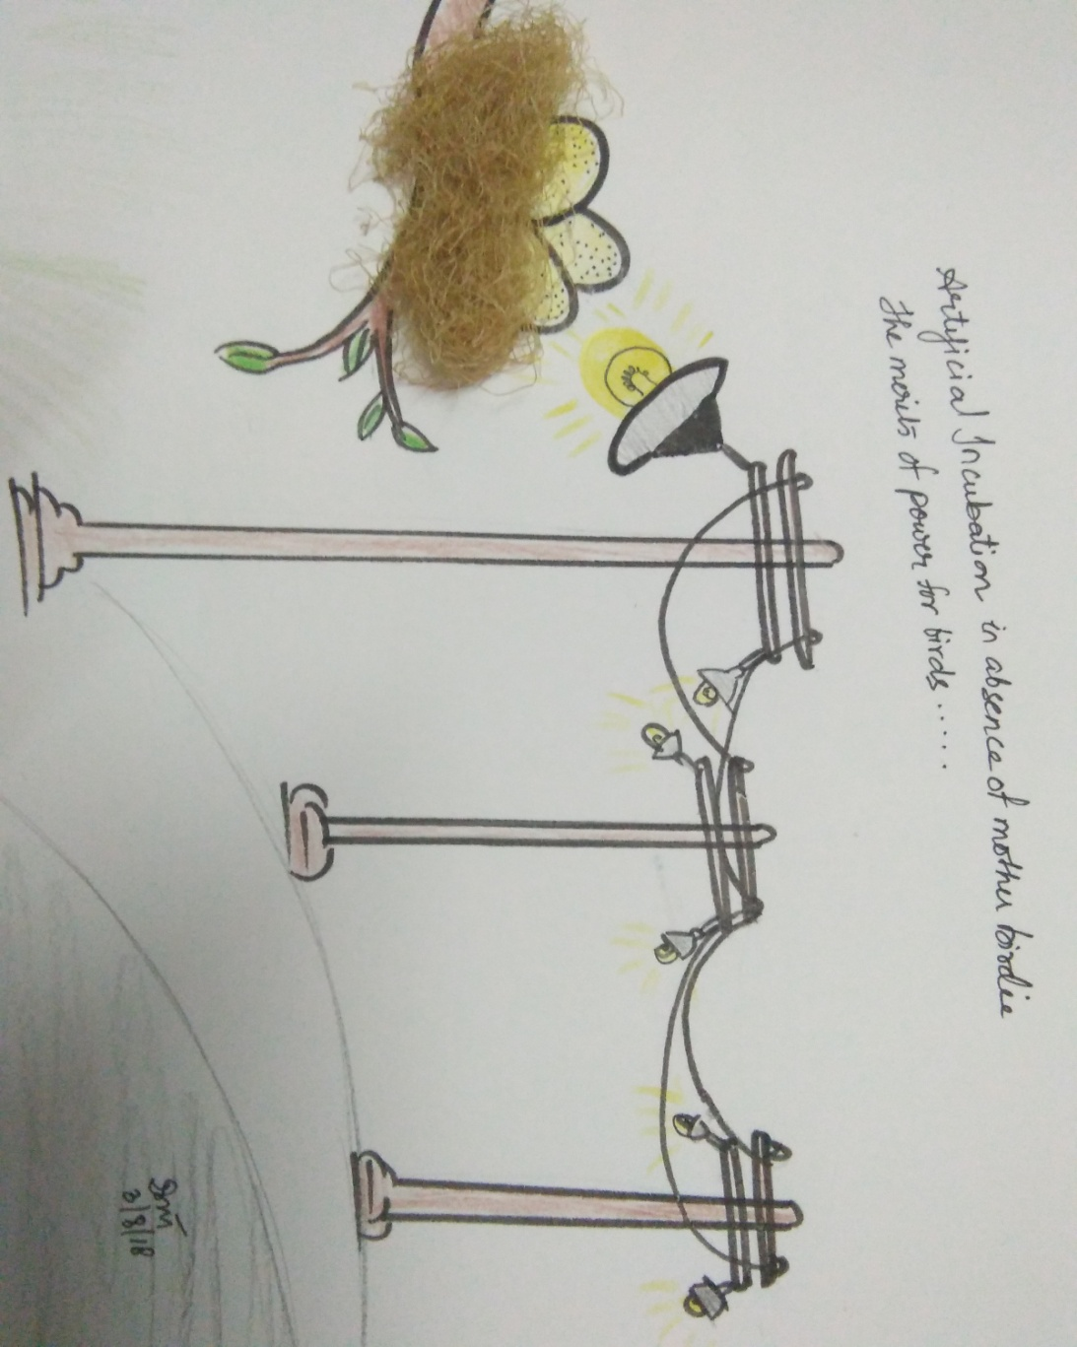

***Light Pollution***

*We are familiar with air, water, and land pollution, but did you know that light can also be a pollutant?*

*The inappropriate or excessive use of artificial light is known as light pollution.*

*Light pollution can have serious environmental consequences for humans, wildlife, and our climate.*

***Losing the dark, polluting night sky****.*

*Artificial incubation in absence of mother birdie, the merits of power poles for birds*.